3: IAM Roles Assignment

You work for XYZ Corporation. To maintain the security of the AWS account and the resources you have been asked to implement a solution that can help easily recognize and monitor the different users. Tasks To Be Performed:

1. Create a role which only lets user1 and user2 from task 1 to have complete access to VPCs and DynamoDB.

2. Login into user1 and shift to the role to test out the feature.

**1. Create a role which only lets user1 and user2 from task 1 to have complete access to VPCs and DynamoDB.**

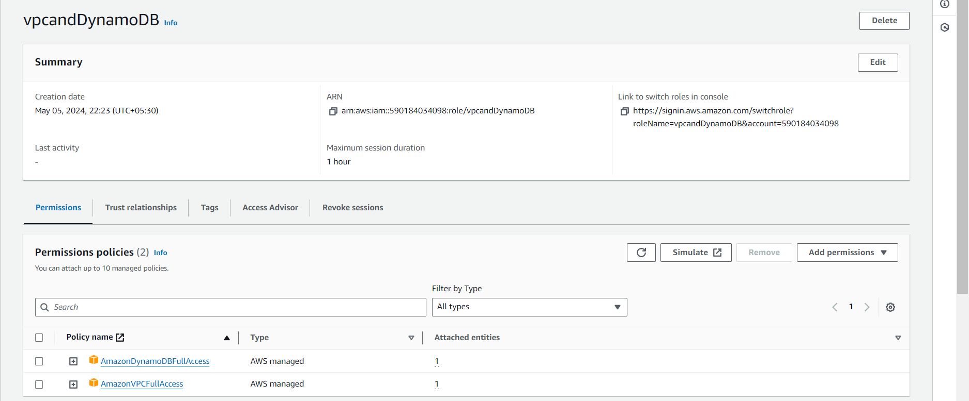

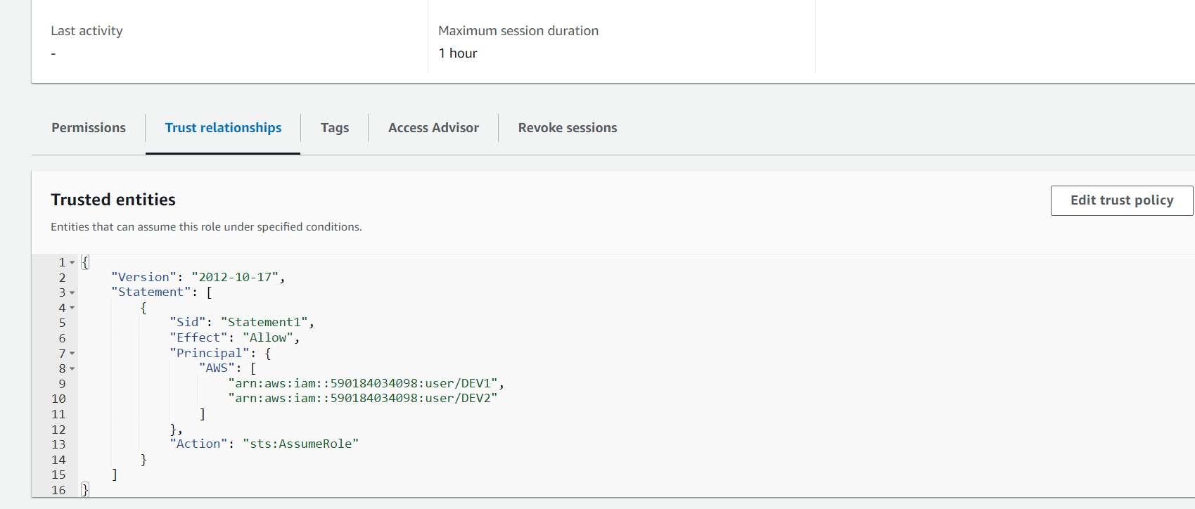

**2. Login into user1 and shift to the role to test out the feature.**

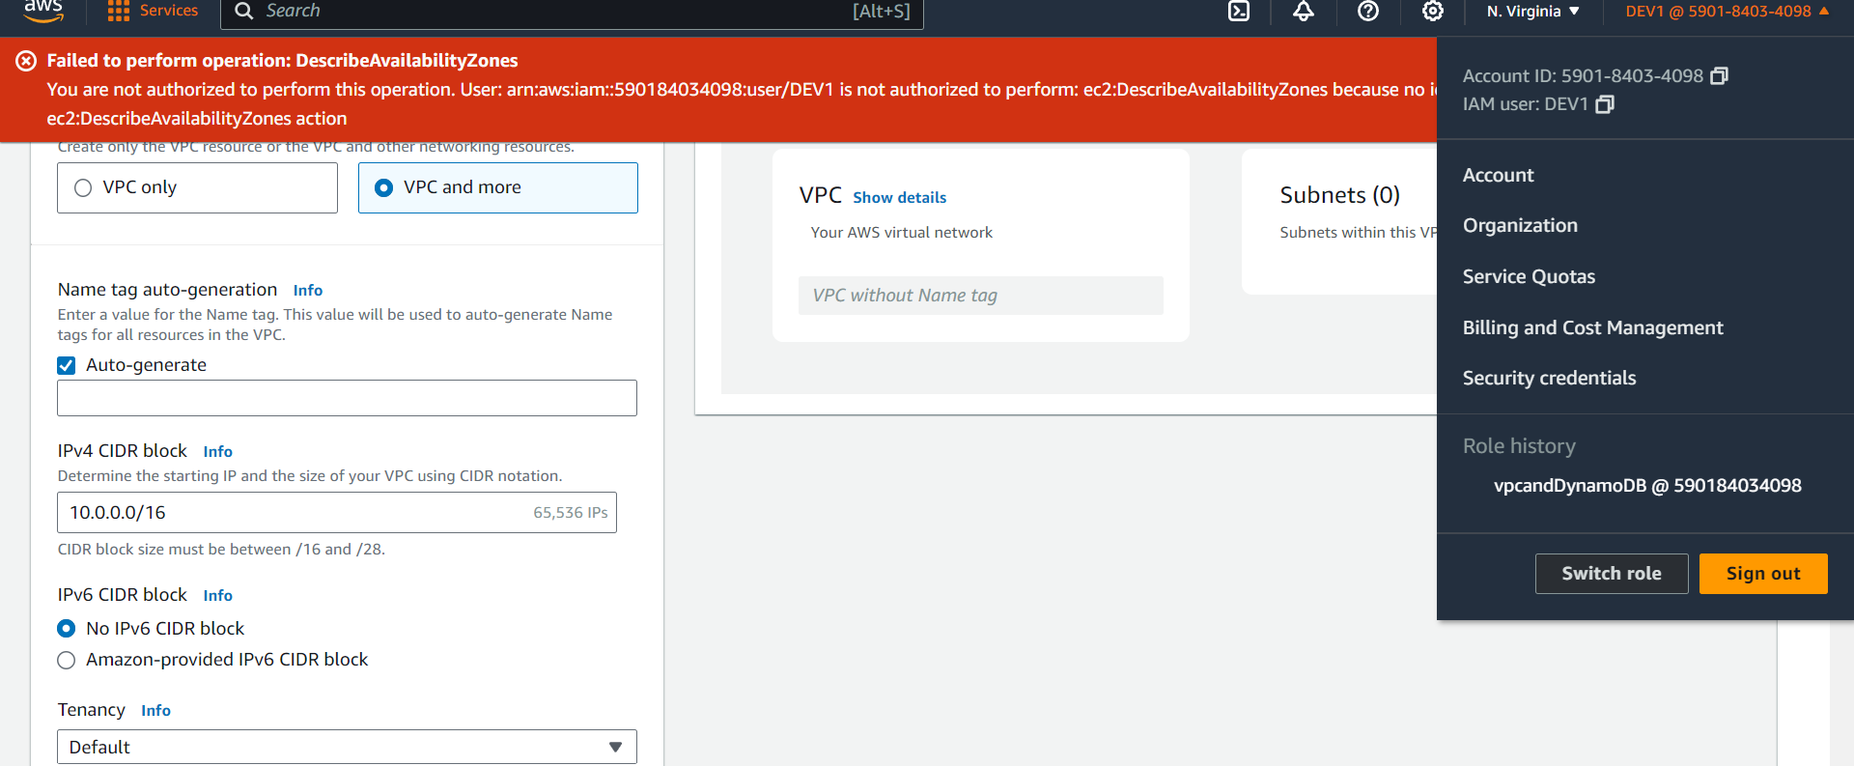

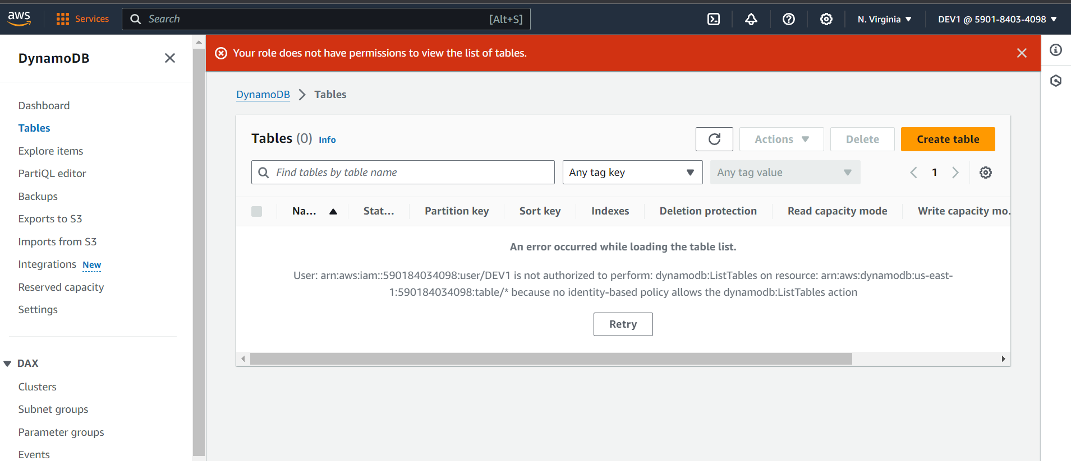

Role switched

